**c**

System Requirements Statement (SRS) –

Virtual Art Gallery

Ab add kardo yaha per.......................

# Introduction

This document explains the system requirements and scope for developing **Virtual Art Gallery.**

**Virtual Art Gallery** could divide the Three main parts, Admin part, Seller part, Buyer part.

This document describes the system requirement of the Account part.

# Functional Requirements

The Account part of Virtual Art Gallery System has four modules which are divided ........... processes described as below.

|  |  |  |
| --- | --- | --- |
| **No** | **BRS requirement ID** | **Description** |
| **2.1** | **Admin Module** | |
| **2.1.1** | **F1** | **Login Process** |
| **2.1.2** | **F2** | **Forgot Password Process** |
| **2.1.3** | **F3** | **Change Password Process** |
| **2.1.4** | **F4** | **Update Account Process** |
| **2.1.5** | **F5** | **View Periodically Transaction** |
| **2.1.6** | **F6** | **View Payment** |
| **2.1.7** | **F7** | **View all Registered artist or seller** |
| **2.1.8** | **F8** | **Create Category** |
| **2.1.9** | **F9** | **Create Brands** |
| **2.1.10** | **F10** | **Remove User** |
| **2.2** | **Artist Module** |  |
| **2.2.1** | **F11** | **Account Creation Process** |
| **2.2.2** | **F12** | **Login Process** |
| **2.2.3** | **F13** | **Forgot Password Process** |
| **2.2.4** | **F14** | **Change Password Process** |
| **2.2.5** | **F15** | **Update Account Process** |
| **2.2.6** | **F16** | **Add Artwork** |
| **2.2.8** | **F18** | **Confirm Order** |
| **2.2.9** | **F19** | **Dispatch Order** |
| **2.2.9** | **F20** | **Payback Process(deposit)** |
| **2.2.10** | **F21** | **Update Artwork Information** |
| **2.2.11** | **F22** | **Delete Artwork** |
|  |  |  |
| **2.3** | **Seller Module** | |
| **2.2.1** | **F23** | **Account Creation Process** |
| **2.2.2** | **F24** | **Login Process** |
| **2.2.3** | **F25** | **Forgot Password Process** |
| **2.2.4** | **F26** | **Change Password Process** |
| **2.2.5** | **F27** | **Update Account Process** |
| **2.2.6** | **F28** | **Add Product** |
| **2.2.7** | **F29** | **Confirm orders** |
| **2.2.8** | **F30** | **Dispatch Orders** |
| **2.2.9** | **F31** | **Update Product (stock) information** |
| **2.2.10** | **F32** | **Delete Product** |
| **2.3 Buyer Module** | | |
| **2.3.1** | **F33** | **Account Creation Process** |
| **2.3.2** | **F34** | **Login Process** |
| **2.3.3** | **F35** | **Forgot Password Process** |
| **2.3.4** | **F36** | **Change Password Process** |
| **2.3.5** | **F37** | **Update Account Process** |
| **2.3.6** | **F38** | **Browse Product** |
| **2.3.7** | **F39** | **Add Product to Cart** |
| **2.3.8** | **F40** | **Manage Cart** |
| **2.3.9** | **F41** | **Buy Product** |
| **2.3.10** | **F42** | **Make Payment** |
| **2.3.11** | **F43** | **Cancel Order** |
| **2.3.12** | **F44** | **Order Status** |

#### 2.3 Admin Module

**•** Administratorshould be responsible for following activities.

### 2.3.1 Login Process

The Virtual Art Gallery system always requires user authentication before using itself, except when a new account is successfully created.

The user authentication demands UserID and Password. The UserID and the Password should be checked in three ways.

1. Admin Authentication Requirements:
   * Admin use their UserID and Password to authenticate.
   * The password and user ID must match those stored in the system.
   * If the user ID and password are not equal to what the admin has registered, admin authentication cannot be provided.
2. Admin Access Verification:
   * After successful basic authentication, the system checks to verify if the user type associated with the user ID is "Admin".
3. Account Status Check:

* The userID status must be active, not suspended.
* Administrators can control the status of user accounts (active, suspended, etc.).

When the three checks are successfully completed, Admin can be placed on the “**Admin Home**” page.

**Admin Home Functionalities:**

The “Admin Home” provides some items described as below.

1. Logout Trigger:
   * Allows the admin to log out from the system.
2. Update Account:
   * Enables the admin to update their own account information.
3. Change Password:
   * Provides the functionality to change the admin's password.
4. Browse Product:
   * Allows the admin to view products in the virtual art gallery.
5. Delete Product:
   * Provides the ability to delete products from the gallery.
6. Manage Registered Artists and Sellers:
   * Allows the admin to view and manage registered artists and sellers.
7. View Payment:
   * Provides access to view payment transactions of artwork and product commission.
8. Create Category:
   * Allows the admin to create new categories for artworks/products.
9. Create Brands:
   * Enables the admin to create new brands associated with artworks/products.
10. View Transactions:
    * Provides access to view transaction history, possibly for auditing or management purposes.

**2.3.2 Forgot Password Process**

When admins lose their password, the recovery method should be provided by the Virtual Art Gallery System.

The recovery method is described as below.

1. Initiating Forgot Password Process:
   * First, the administrator logs into the Virtual Art Gallery System using their UserID.
2. Email Verification:
   * The administrator then inputs the email address linked to their account at the time of registration.
3. Email Validation:
   * An email with a new password is sent to the administrator if the email address entered is accurate and matches the one associated with the account.
4. New Password Generation:
   * The Virtual Art Gallery System generates the new password automatically.
5. Admin Authentication with New Password:
   * It must have a minimum of one numeric digit, one uppercase letter, one lowercase letter, and one special character, and it must be between eight and sixteen characters long.
   * The system administrator can verify their identity and gain access by using the new password that they received through email.
6. Changing Password:
   * For security purposes, it is advised that the administrator manually changes the new password after logging in.

### Change Password Process

When an administrator wants to change their password, the Virtual Art Gallery system offers a secure process that requires admin authentication. Here is a step-by-step procedure.

1. **Access the Change Password Function:**
   * This function is available only after the admin has authenticated themselves**.**
2. **Input Current and New Passwords:**
   * The administrator must enter their current password.
   * The administrator must enter the new password twice to avoid typing errors.
3. **Password Requirements:**
   * The new password must be between 8 and 16 characters.
   * It must include at least one numeric figure, one capital letter, one lowercase letter, and one special character.
4. **Password Masking:**
   * Both the current and new passwords are masked with dummy characters for security**.**
5. **Validation:**
   * The system checks if the current password is correct.
   * If correct, the password is updated to the new one.
6. **Re-authentication:**
   * After the password is successfully changed, the system requires the admin to authenticate again.

### Update Account Process

The Virtual Art Gallery provides a function for Admins to update their account information. Here’s what can be updated:

1. Login Information:
   * First Name
   * Last Name
   * Email Address
   * All fields are required but updating them is optional.
2. User Information:
   * Username
   * Phone Number
   * Email Address
   * Permanent Address
   * All fields are required but updating them is optional.
3. Password Verification:
   * The admin must enter their current password.
   * If the password is correct, the updates will be applied.

#### Generating report

The Virtual Art Gallery system provides the following reporting features for Admins:

1. View User Records:
   * Admins can see all records from any user, including login history, transactions, and profile updates.
2. Daily Enrollment Report:
   * Admins get a daily report of new user enrollments.
3. Monthly Enrollment Report:
   * Admins receive a monthly report showing user enrollments.
4. Transaction Reports:
   * Admins can see detailed reports on all transactions, including sales and refunds.
5. Activity Log Reports:
   * Admins can access logs of user activities, like product uploads and updates.
6. System Performance Reports:
   * Admins can review reports on system performance, such as uptime and error rates.

#### Accounts Management

• Admin should able to manage all the accounts with following activities,

1. Enable accounts:
   * Activate user accounts to grant access to the system.
2. View Account Status:
   * Activate user accounts to grant access to the system.
3. Disable accounts:
   * Deactivate user accounts to restrict access to the system.

#### View Periodically Transactions

The "View Periodic Transaction" function in the Virtual Art Gallery system allows administrators to monitor and examine transactions across certain time periods. Here is a thorough description of this feature.

1. Access Transaction Data:
   * Admins can access detailed transaction records within the system.
2. Specify Time Periods:
   * Admins can select specific time periods (daily, weekly, monthly, quarterly, annually) to view transactions.
3. Filter Options:
   * Admins can filter transactions by various criteria such as date range, transaction type (sales, refunds, etc.), user, product category, and payment method.
4. Transaction Details:

View comprehensive details of each transaction, including:

* + Transaction ID
  + Date and time of the transaction
  + User information (buyer and seller details)
  + Product details (name, category, price)
  + Payment method and status
  + Any applied discounts or promotions

1. Generate Reports:
   * Admins can generate and export transaction reports in various formats (PDF, Excel, etc.) for further analysis or record-keeping.
2. Summarized Views:
   * Admins can see summarized views of transactions, such as total sales, total refunds, and net revenue for the selected period.
3. Graphical Representations:
   * The system provides graphical representations (charts, graphs) to help visualize transaction trends and patterns over time.
4. Audit and Compliance:
   * Analyze transaction logs to ensure that all transactions maintain to the gallery's standards and to discover any unusual or suspicious activity.

#### View System Payment

Admins can use the "View System Payment" function to manage payments from artists and sellers in the following steps:

1. Access Payment Records:
   * View detailed records of payments received from artists and sellers.
2. Filter and Search:
   * Filter payments by date, status (completed, pending, failed), payment method, and amount.
   * Easily search for specific transactions.
3. Payment Details:
   * See key details for each payment, including payment ID, date, artist/seller details, payment method, amount, and status.
4. Analysis and Reports:
   * Analyze payment trends and generate reports summarizing total payments received and pending over selected periods.

#### View all Registered artist or seller

Admins can easily view all registered artists or sellers in the Virtual Art Gallery system with the following steps:

1. Access Registered Users:
   * Admins have direct access to a list of all registered artists and sellers.
2. View Basic Information:
   * See each artist or seller's username, contact information, and registration date.
3. Filter and Search:
   * Filter the list based on specific criteria like registration date, account status (active, inactive), or category (artist, seller).
4. Manage Accounts:
   * Admins can take actions like enabling or disabling accounts, updating user information, or reviewing transaction history as needed.

#### Create Category for artist or seller

Administrators can create categories for artists or sellers in the Virtual Art Gallery system by following these simple steps:

1. Access Category Management:
   * Administrators access to the category management section, which is particularly created for artists and sellers.
2. Define Category Details:
   * Enter a name and description for the new category. This allows you to properly categorize artworks or products.
3. Assign to Artists or Sellers:
   * Choose whether this category applies to artists or sellers. This ensures clarity in product categorization
4. Save and Apply:
   * Save the category creation. Artists and sellers can now select this category when uploading their artworks or products.

#### Create Brands for seller

Admins can create brands for sellers in the Virtual Art Gallery system with the following simple steps:

1. Access Brand Management:
   * Admins access to the brand management section for sellers.
2. Define Brand Details:
   * Enter the name and description of your new brand. This allows sellers to properly identify their products.
3. Assign to Sellers:
   * Administrators may grant a brand to all Virtual Art Gallery sellers. This ensures that the brand is used regularly all products from various sellers.
4. Save and Apply:
   * Save the brand creation. Sellers can now associate this brand with their products when listing them.

#### Remove User

Admin can easily remove users from the Virtual Art Gallery website by following these steps:

1. Access User Management:
   * Log in to the admin dashboard and navigate to the user management section.
2. Select User Profile:
   * Locate and select the user profile to be removed.
3. Choose Removal Option:
   * Decide whether to delete the user account.
4. Confirm Deletion or Disablement:
   * Confirm the action to delete the user account permanently.
5. Review and Finalize:
   * Double-check the removal request before finalizing to ensure accuracy and completeness.

#### 2.2 Artist Module

* Artist is the user of System who can Display his Artwork on System
* Artist can sell or give in rent his/her Artwork on System

#### 2.2.1 Account Creation Process

* Virtual Art Gallery System compels to create the account before using it. So, it should provide the function which makes Artist creates new account.
* When user creates new account, the function demands four information described as below.

1. Login information
2. Contact Details

* The Login information

The Login information consists of some items described as below.

1. User ID
2. Password
3. First Name
4. Last Name
5. E-mail address
6. User Type
   1. All items are compulsory demanded.
   2. User ID

* The User ID should be unique. If the UserID correspond with not case-sensitive to other which is previously registered, the UserID should not be registered as an account.
  1. Password
* The Password has constrained which makes the Password consists of more than or equal 8 and less than or equal 16 characteristics including characters described as below.

1. Numeric figure (at least one)
2. Capital alphabet (A-Z) (at least one)
3. Small alphabet (a-z) (at least one)
4. Special character (#, $, %, &, etc.) (at least one)

* The Password is masked by dummy characters. The re-entering Password is demanded.
* The Password must be encrypted in Virtual Art Gallery system.
  1. User Type

The User Type falls into three categories described as below.

1. Artist
2. Seller
3. Administrator

* The User Type also defines three types of user "Artist", "Seller", and "Administrator user”.
* No one could select The Administrator, because Administrator is implemented to Virtual Art Gallery System in advance.
* Contact Details
* The Contact Detail consists of some items described as below.

1. Permanent Address
2. Contact Phone No
   1. All items are compulsory demanded.
   2. Permanent Address

* Permanent Address should be filled.
* But only the state should be selected from options.
* The Security Question information

The Security Question information is needed when user lost their Password. This information consists of two items described as below.

1. Selected Question
2. Answer
   1. All items are compulsory demanded.
   2. Some questions which are difficult to answer for anyone else are prepared in advance.

E.g. which color do you like most?

* 1. A question should be selected from options by the user, and the Answer is registered by the user.
* Login information should be entered on one screen, and then user information and Security Question information should be entered on another screen.

### 2.2.2 Login Process

* The Virtual Art Gallery requires user authentication before granting access, except immediately after a successful account creation.
* The user authentication demands User ID and Password. The User ID and the Password should be checked in three ways.
  1. First, The User ID and the Password should be existed and correct.
* If The User ID and the Password are not equal to what the user has registered, the user authentication cannot be provided.
  1. Second, the User Type linked to the User ID should be "User".
* When the User Type is "User", then user can be placed on “Home Page”.
  1. Finally, User ID should be available.
* The Administrator can decide whether the User ID is available or suspended – Refer to the SRS of the Admin part.
* If user is rejected, user authentication is not provided for system user.
* The user account should alive for so long as the duration decided by Admin.
* Only when the three checks are successfully completed, user can be placed on respected page.
* The “Home Page” provides some items described as below.

1. A trigger to logout
2. A trigger to update Account
3. A trigger to Change Password
4. A trigger to Search Product
5. A trigger to Publish Product for sale
6. A trigger to Update Product Information
7. A trigger to Delete Product
8. A trigger to Browse existing Market price

### 2.2.3 Forgot Password Process

* When system user lost their Password, the recovery method should be provided by website.

The recovery method is described as below.

* 1. First, system user enters their UserID.
  2. Next, System demands the Answer which has been registered since when the Account was created.
  3. Only when the Answer is correct, farmer get the new password by E-mail which also has been registered since when the Account was created.
  4. The new password is automatically generated by System.
* Of course, the new password should consist of more than or equal 8 and less than or equal 16 characteristics including at least a numeric figure, a capital alphabet, a small alphabet, and a special character.
* As a consequence, The Farmer could get the user authentication using the new password.
  1. Then, the user had better change the new password manually.
* If the Answer is not correct, otherwise, the correct Answer is demanded for user again.
  1. In that case, Of course, user could not get the new password.

### 2.2.4 Change Password Process

* When user wants to change their Password, the measure should be provided by system.
* Therefore, system should provide the function which is available after getting the user authentication.
* The function demands the current password and the new password.
  1. Of course, the new password should consist of more than or equal 8 and less than or equal 16 characteristics including at least a numeric figure, a capital alphabet, a small alphabet, and a special character.
  2. The current password and the new password are masked by using dummy characters.
  3. The new password is demanded to enter twice to avoid a typing error.
* Only when the current password is correct, user could change their Password.
* When the current password is changed into new password, Virtual Art Gallery mandates user authentication again.

### 2.2.5 Update Account Process

* Virtual Art Gallery should provide the function which makes the account updated for user.
* The information user could update is described below.

1. Login information
2. User information
3. Security Question Information

* The Login information

The updatable items as described below.

1. First Name
2. Last Name
3. E-mail address
   1. All items are compulsory demanded, but updating is optional.

* The User information

The updatable items as described below.

1. User Name
2. User Phone No
3. E-mail address
4. Permanent address
   1. All items are compulsory demanded, but updating is optional.

* The Security Question information

The updatable items as described below.

1. Selected Question
2. Answer
   1. All items are compulsory demanded, but updating is optional

2.2.6 Add Artwork

* Artists can submit their works to the Virtual Art Gallery System for exhibition, purchase, or rental.
* For artists to properly manage their directory and exhibit their works, this function is essential.

1. Artist ID – Each artist has a unique ID that they use to identify themselves when they upload artwork.
2. Category – The category that the artwork falls under
   * + - Painting
       - Sculpture
       - Snapshots
3. Subcategory – A division situated inside the selected category
   * + - Synopsis
       - Scenery
       - picture
4. Price – If the artwork is for sale, the selling price
5. Choose option -
   * + - Rent – If the artwork is for rent, the specifics of the rental agreement
         1. Duration of rent
         2. The rent amount
       - Sell – Extra information about the artwork's sale
         1. Options for shipping
         2. Details of packing
6. Packaging – Give options for several packaging styles that go well with the artwork.
   * + - 1. cardboard container
         2. wooden boxes
         3. Wrapped in bubbles
         4. Present wrapping

2.2.8 Confirm Order

* + The "View Order Details" function provides artists with access to comprehensive information regarding orders placed by customers for their artworks within the Virtual Art Gallery System.
  + It serves as a crucial tool for order management and customer service.
  1. Artwork_id - Identification number of the artwork for which orders are to be viewed.
  2. Buyer Adress -
     1. Customer's name
     2. Address
     3. Contact information.
  3. Artwork details -
     1. Artwork ID
     2. Title
     3. Category
     4. Price
  4. **Order Status -** Current status of the order
     1. Pending
     2. Processing
     3. Shipped
  5. Payment Status - Payment details
     1. Paid
     2. Pending payment
  6. Order timestamp - Date and time when the order was placed

2.2.9 Dispatch Order

* + Enable artists see every order that has been shipped that is connected to their work.
  1. Artwork_id - Identification number of the artwork for which orders are to be viewed.
  2. Dispatched Date - The date on which the artwork order was shipped out.
  3. Order Id - A distinct number linked to every order that is placed within the system.

2.2.10 Payback Process(deposit)

if customer return the artwork, then payback process will be done. Then only Payback option visible for that customer.

1. Proceed to Pay.
   * Buyer Account Details -

Buyer account details will be added automatically by the system

this account details are given by Buyer at the time of took art on

the rent.

* + Mobile Number -

Artist able to contact the Buyer and Inform the Buyer that his payment

is procced.

* + Send Back Money -

This option will send the money to the Buyer.

2.2.11 Update Artwork Information

if Artist wants to update the price, then he/she able to update it.

1. Category
2. Subcategory
3. Price
4. Other Details

2.2.12 Delete Artwork

If artist want to delete his artwork from the system, then he is able to delete it.

1. Delete your Artwork

a. Delete All

b. Select any one

#### 2.2 Seller Module

#### **2.2.1 Account Creation Process**

* Virtual Art Gallery compels to create the account before using it. So Virtual Art Gallery should provide the function which makes farmer creates new account.
* When seller creates new account, the function demands four information described as below.

1. Login information

2.Contact Details

3.Security Question Information

4.Payment information.

* The Login information

The Login information consists of some items described as below.

5.UserID

6.Password

7.First Name

8.Last Name

9.E-mail address

10.User Type

* 1. All items are compulsory demanded.
  2. User ID
* The User ID should be unique. If the UserID correspond with not case-sensitive to other which is previously registered, the UserID should not be registered as an account.
  1. Password
* The Password has constrained which makes the Password consists of more than or equal 8 and less than or equal 16 characteristics including characters described as below.

1.Numeric figure (at least one)

2.Capital alphabet (A-Z) (at least one)

3.Small alphabet (a-z) (at least one)

4.Special character (#, $, %, &, etc.) (at least one)

* The Password is masked by dummy characters. The re-entering Password is demanded.
* The Password must be encrypted in Virtual Art Gallery System.
  1. User Type

The User Type falls into three categories described as below.

1.Admin

2.Seller

3.Buyer

* The User Type also defines three types of users; " Admin user", "Seller user", and "Buyer user”.
* In an Account Creation Process, the user can select Seller.
* No one could select The Admin, because Admin is implemented to Virtual Art Gallery System in advance.
* Contact Details
* The Contact Detail consists of some items described as below.

1.Permanent Address

2.Contact Phone No

* 1. All items are compulsory demanded.
  2. Permanent Address
* Permanent Address should be filled.
* But only the state should be selected from options.
* The Security Question information

The Security Question information is needed when Seller lost their Password. This information consists of two items described as below.

1. Selected Question
2. Answer
   1. All items are compulsory demanded.
   2. Some questions which are difficult to answer for anyone else are prepared in advance.

E.g. which color do you like most?

* 1. A question should be selected from options by the Seller, and the Answer is registered by the Buyer.
* Login information should be entered on one screen, and then Seller information and Security Question information should be entered on another screen.

### 2.2.2 Login Process

* Virtual Art Gallery System always compels Seller authentication before using itself except when a new account is successfully created.
* The user authentication demands UserID and Password. The UserID and the Password should be checked in three ways.
  1. First, The UserID and the Password should be existed and correct.
* If The UserID and the Password are not equal to what the user has registered, the user authentication cannot be provided.
  1. Second, the User Type linked to the UserID should be "user".
* When the User Type is " Seller", user can be placed on “Seller Home”.
  1. Finally, UserID should be available.
* The Administrator can decide whether the UserID is available or suspended – Refer to the SRS of the Admin part.
* If user is rejected, user authentication is not provided for Seller.
* The Seller account should alive for so long as the duration decided by Admin.
* Only when the three checks are successfully completed, Seller can be placed on respected page.
* The “Seller Home” provides some items described as below.

1. A trigger to logout
2. A trigger to update Account
3. A trigger to Change Password
4. A trigger adds products
5. A trigger to Delete Product
6. A trigger to view orders
7. Dispatch Orders

### 2.2.3 Forgot Password Process

* When Seller lost their Password, the recovery method should be provided by Virtual Art Gallery.

The recovery method is described as below.

* 1. First, Seller enters their UserID for Virtual Art Gallery.
  2. Next, Virtual Art Gallery demands the Answer which has been registered since when the Account was created.
  3. Only when the Answer is correct, seller get the new password by E-mail which also has been registered since when the Account was created.
  4. The new password is automatically generated by Virtual Art Gallery.
* Of course, the new password should consist of more than or equal 8 and less than or equal 16 characteristics including at least a numeric figure, a capital alphabet, a small alphabet, and a special character.
* As a consequence, the seller could get the user authentication using the new password.
  1. Then, the seller had better change the new password manually.
* If the Answer is not correct, otherwise, the correct Answer is demanded for seller again.
  1. In that case, Of course, seller could not get the new password.

### 2.2.4 Change Password Process

* When seller wants to change their Password, the measure should be provided by Virtual Art Gallery.
* Therefore, Virtual art Gallery should provide the function which is available after getting the seller authentication.
* The function demands the current password and the new password.
  1. Of course, the new password should consist of more than or equal 8 and less than or equal 16 characteristics including at least a numeric figure, a capital alphabet, a small alphabet, and a special character.
  2. The current password and the new password are masked by using dummy characters.
  3. The new password is demanded to enter twice to avoid a typing error.
* Only when the current password is correct, seller could change their Password.
* When the current password is changed into new password, Virtual art Gallery compels seller authentication again.

### 2.2.5 Update Account Process

* Virtual art Gallery should provide the function which makes the account updated for seller.
* The information seller could update is described below.

1. Login information

2. User information

3. Security Question Information

* The Login information

The updatable items as described below.

1. First Name
2. Last Name
3. E-mail address
   1. All items are compulsory demanded, but updating is optional.

* The User information

The updatable items as described below.

1. User Name
2. User Phone No
3. E-mail address
4. Permanent address
   1. All items are compulsory demanded, but updating is optional.

* The Security Question information

The updatable items as described below.

1. Selected Question
2. Answer
   1. All items are compulsory demanded, but updating is optional.

#### 2.2.6 Add Product

1.Create an account: -Artist can sign up for an account on virtual art gallery platform and fill out a registration form with their details.

2.Submit artwork: -Artist can upload their artwork to the platform, include images and provide relevant information such as title, description and price.

3.Fill out products details:Artists can fill out a product details form with information (if applicable).

4.Review and confirm:- The platform moderators will review the submitted artwork and confirm its inclusion in the virtual gallery.

* + Select Brand
  + Category
  + Sub category
  + Price
  + Details
  + Stock details(quantity)

#### 2.2.8 Confirm Orders

1.Login to account: Customer can log in their account on the virtual art gallery platform using their username and password.

2.Go to the order History: Click “Order History” view all past and current orders.

3.View order details: Click on an order to view the details

1. Seller is able to view the order received by the buyer.

a. view orders

#### 2.2.8 Dispatch Orders

1.Customer place order: A Customer selects the artwork they wish to purchase and clicks the “Buy Now” button.

2.Order summary: -The Platform generates an order summery like artwork details, price and customer information.

3. Order conformation: -The customer reviews and confirm their order details, including shipping address and payment method.

4. Seller is able to view the All-dispatched orders

* 1. Dispatched
  + Product ID
  + Customer id
  + Status
  + Date of Dispatch

**2.2.9 Update Product Information**

• If seller want to Update the Product Information like price of the product, quantity available of the that product then seller will be able to make changes using the Update Product.

1. Update
   1. Price
   2. Details
   3. Stock Available

**2.2.10 Delete Product**

* If Seller wants to delete his product from System. Then he or she will able to delete it from Virtual Art Gallery.
  1. Delete All

if seller wants to Delete his all the product, then system will allow the seller to delete all the Product by using this option

* 1. Select anyone

If seller wants to delete Specific product, then he is able to delete it.

By choosing the option given to the seller

options contains only those product which are added by that particular seller only.

## Buyer Module

* Buyer is the user of system who wants to buy the products.
* He/ She is also able to view the prices of products on the website.
* Buyers can also purchase the raw material required for the Artwork.
* Buyer can have subscription to Art work present on website.

### Account Creation Process

* Virtual Art Gallery System compels to create the account before using it. So, it should provide the function which makes Artist creates new account.
* When user creates new account, the function demands four information described as below.

1. Login information
2. Contact Details

* The Login information

The Login information consists of some items described as below.

1. User ID
2. Password
3. First Name
4. Last Name
5. E-mail address
6. User Type
7. Permanant Address
   1. All items are compulsory demanded.
   2. User ID

* The User ID should be unique. If the UserID correspond with not case-sensitive to other which is previously registered, the UserID should not be registered as an account.
  1. Password
* The Password has constrained which makes the Password consists of more than or equal 8 and less than or equal 16 characteristics including characters described as below.

1. Numeric figure (at least one)
2. Capital alphabet (A-Z) (at least one)
3. Small alphabet (a-z) (at least one)
4. Special character (#, $, %, &, etc.) (at least one)

* The Password is masked by dummy characters. The re-entering Password is demanded.
* The Password must be encrypted in Virtual Art Gallery system.
  1. User Type

The User Type falls into three categories described as below.

1. Artist
2. Seller
3. Administrator

* The User Type also defines three types of user "Artist", "Seller", and "Administrator user”.
* No one could select The Administrator, because Administrator is implemented to Virtual Art Gallery System in advance.
* Contact Details
* The Contact Detail consists of some items described as below.

1. Permanent Address
2. Contact Phone No
   1. All items are compulsory demanded.
   2. Permanent Address

* Permanent Address should be filled.
* But only the state should be selected from options.
* The Security Question information

The Security Question information is needed when user lost their Password. This information consists of two items described as below.

1. Selected Question
2. Answer
   1. All items are compulsory demanded.
   2. Some questions which are difficult to answer for anyone else are prepared in advance.

E.g. which color do you like most?

* 1. A question should be selected from options by the user, and the Answer is registered by the user.
* Login information should be entered on one screen, and then user information and Security Question information should be entered on another screen.

### Login Process

* The Virtual Art Gallery requires user authentication before granting access, except immediately after a successful account creation.
* The user authentication demands User ID and Password. The User ID and the Password should be checked in three ways.
  1. First, The User ID and the Password should be existed and correct.
* If The User ID and the Password are not equal to what the user has registered, the user authentication cannot be provided.
  1. Second, the User Type linked to the User ID should be "User".
* When the User Type is "User", then user can be placed on “Home Page”.
  1. Finally, User ID should be available.
* The Administrator can decide whether the User ID is available or suspended – Refer to the SRS of the Admin part.
* If user is rejected, user authentication is not provided for system user.
* The user account should alive for so long as the duration decided by Admin.
* Only when the three checks are successfully completed, user can be placed on respected page.
* The “Home Page” provides some items described as below.

1. A trigger to logout
2. A trigger to update Account
3. A trigger to Change Password
4. A trigger to Search Product
5. A trigger to Publish Product for sale
6. A trigger to Update Product Information
7. A trigger to Delete Product
8. A trigger to Browse existing Market price

### Forgot Password Process

* When system user lost their Password, the recovery method should be provided by website.

The recovery method is described as below.

* 1. First, system user enters their UserID.
  2. Next, System demands the Answer which has been registered since when the Account was created.
  3. Only when the Answer is correct, farmer get the new password by E-mail which also has been registered since when the Account was created.
  4. The new password is automatically generated by System.
* Of course, the new password should consist of more than or equal 8 and less than or equal 16 characteristics including at least a numeric figure, a capital alphabet, a small alphabet, and a special character.
* As a consequence, The Farmer could get the user authentication using the new password.
  1. Then, the user had better change the new password manually.
* If the Answer is not correct, otherwise, the correct Answer is demanded for user again.
  1. In that case, Of course, user could not get the new password.

### Change Password Process

* When user wants to change their Password, the measure should be provided by system.
* Therefore, system should provide the function which is available after getting the user authentication.
* The function demands the current password and the new password.
  1. Of course, the new password should consist of more than or equal 8 and less than or equal 16 characteristics including at least a numeric figure, a capital alphabet, a small alphabet, and a special character.
  2. The current password and the new password are masked by using dummy characters.
  3. The new password is demanded to enter twice to avoid a typing error.
* Only when the current password is correct, user could change their Password.
* When the current password is changed into new password, Virtual Art Gallery mandates user authentication again.

### Update Account Process

* Virtual Art Gallery should provide the function which makes the account updated for user.
* The information user could update is described below.

1. Login information
2. User information
3. Security Question Information

* The Login information

The updatable items as described below.

1. First Name
2. Last Name
3. E-mail address
   1. All items are compulsory demanded, but updating is optional.

* The User information

The updatable items as described below.

1. User Name
2. User Phone No
3. E-mail address
4. Permanent address
   1. All items are compulsory demanded, but updating is optional.

* The Security Question information

The updatable items as described below.

1. Selected Question
2. Answer
   1. All items are compulsory demanded, but updating is optional.

### Browse product

Buyer is Able to Search Product and Artwork in Different ways as he wants to search.

Browse option will provide User friendly environment.

* Search conditions are described as below.

1. Product category

Buyer is able to search the Product and art by the category name.

1. Price range

If any Buyer want to search according to the Price of the product, then he will be able to search according to the price range.

And result will be given as per the range given by the buyer.

1. User can search artwork created by artist

If any user wants to search the Artwork for any specific artist, then he is able to search according to that result will be display to the user.

1. User can search material by Title

If User wants to search product by the Title of the Product or

artwork then they will be able to search according to that also.

### 2.1.7 Adding product to cart

* Publish products requirements are described as below.
* By Adding the Art into Cart Buyer is able buyer is able to view the total bill of his/her Wishlist.
* Also, by Adding the Artwork to cart buyer is able to save the artwork for future.

1. Add to cart

### 2.1.8 Manage Cart

* Buyer is able to add various arts from the System.
* If Buyer wants to add one more art in his Wishlist then he is able to add it the cart.
* Also, if Buyer wants to remove the artwork from the Cart, then he is able to delete by choosing the Delete option.

1. View artwork
2. Remove
   * Select art to remove
   * Remove

### 2.1.9 Buy Product

* Buying product having following process.

1. Select quantity of product
2. Select address
3. Procced to payment page

### 2.1.10 Make Payment

• Users enter their payment details, which may include credit card information, PayPal account details, etc.

1. Select the mode of payment
2. Payment for cash on delivery
3. Payment done

### 2.1.11 Cancel Order

• user could see the information of existing products.

* 1. View order
     + By clicking on the orders menu buyer can see all orders.
  2. Select order
     + From all the orders buyer can select one product or multiple products to cancel.
  3. Cancel order
     + Cancel button for confirming the cancel order.
  4. Reason for cancelling the order
     + Reasons of menu given for cancelling the order so that afterwards admin can check the statistics of
  5. Cancel Order
  + Select which order want to select.
  + Address
  + Account Details

### 2.1.11 Order Status

• user could see the information of existing products.

1. Select order
   * + Buyer can view all orders and select one particular order.
2. Show status
   * + Buyer can check all orders and select one order and then they can check the status as confirmed or Not Confirmed.
     + Delivered or Not Delivered Status will be shown.

#### 2.5 Use Case Diagram

**Admin:**

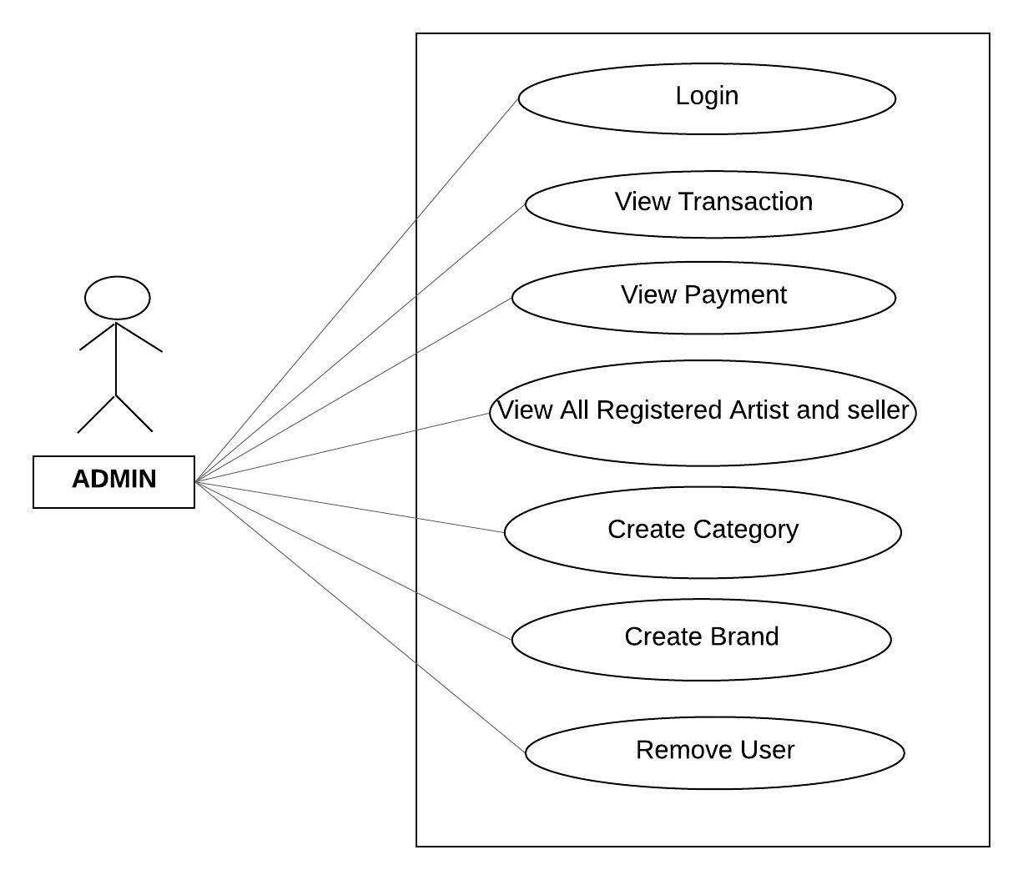

*Fig. Use case diagram for admin*

1. In Admin use case diagram Admin is the Actor.
2. Admin can handle following use cases:
3. Login
4. View Transaction
5. View Payment
6. View registered Artist and seller
7. Create Category
8. Create Brand
9. Remove User

**Artist:**

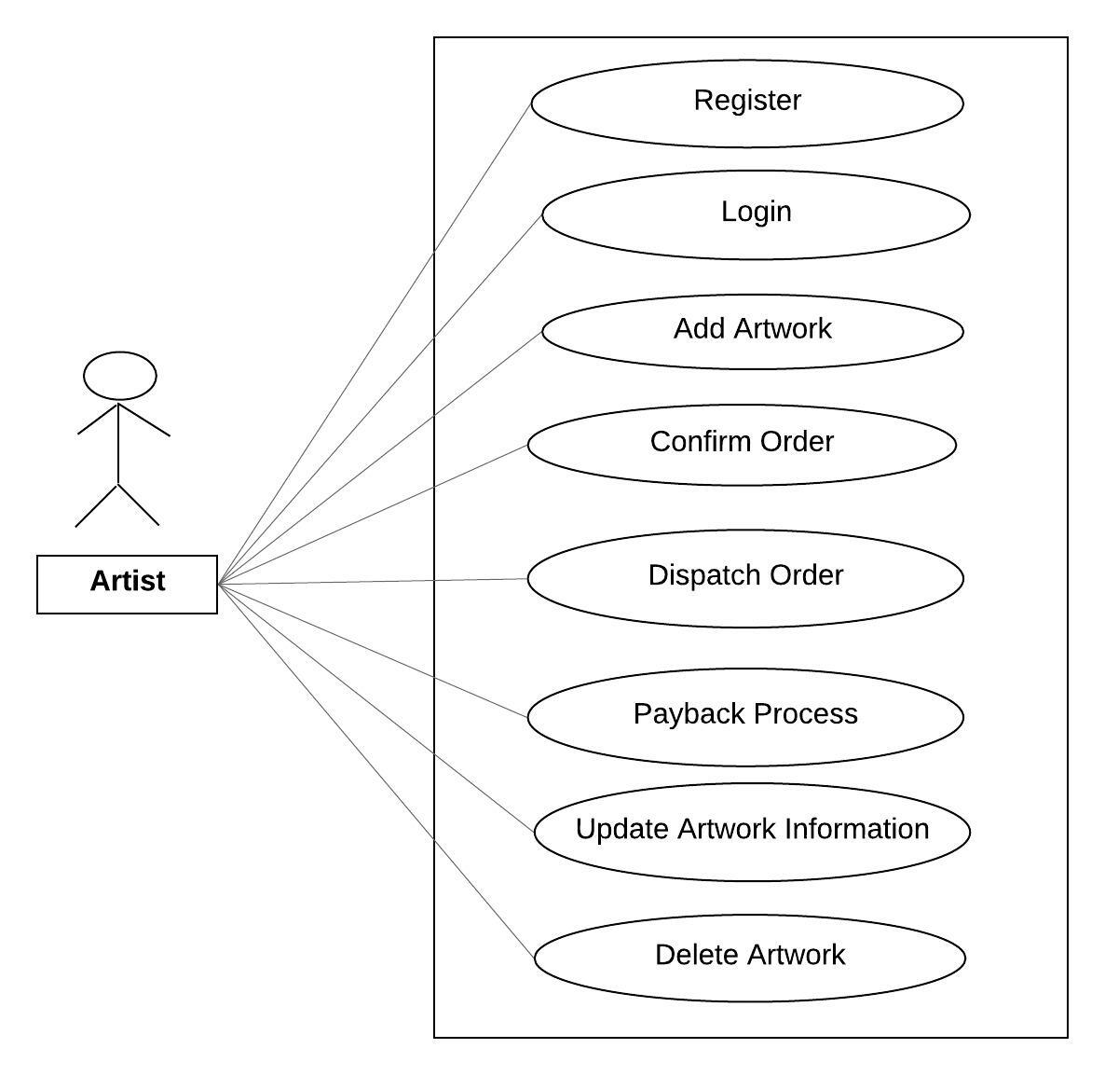

*Fig. Use case diagram for Artist*

1. In artist use case diagram artist is the Actor.
2. Artist can handle following use cases:
3. Register
4. Login
5. Add Artwork
6. Confirm Order
7. Dispatch order
8. Payback Deposit
9. Update Artwork Information
10. Delete Artwork

**Seller:**

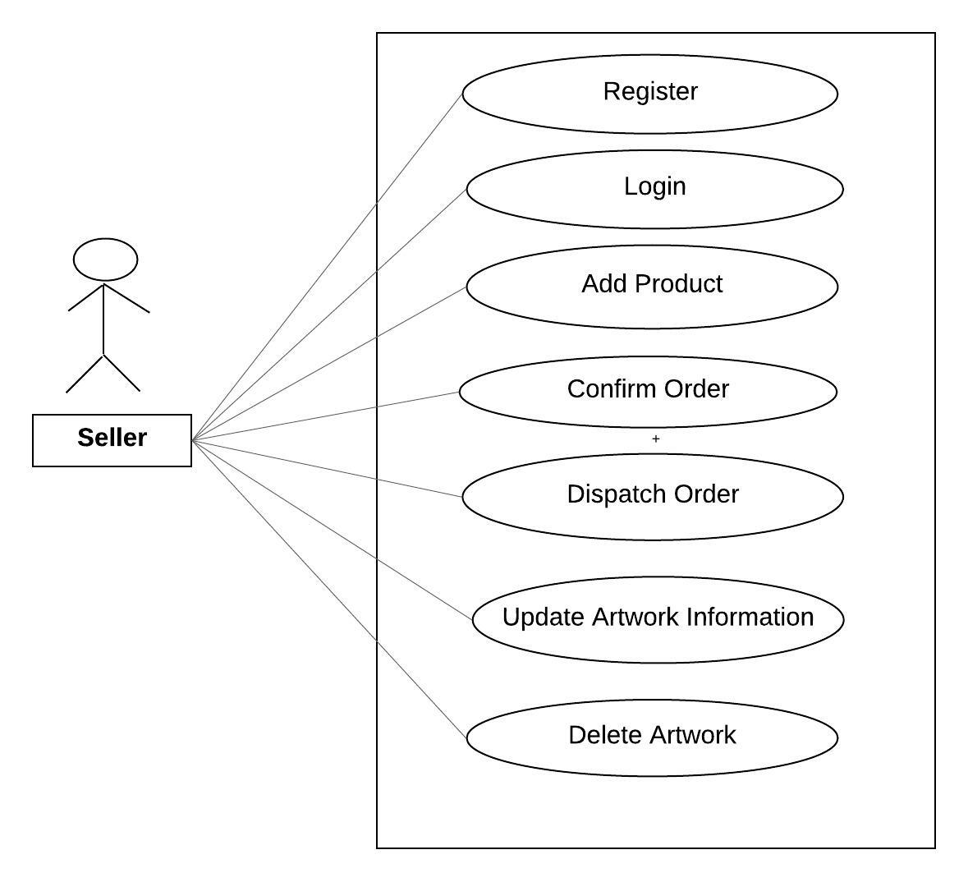

*Fig. Use case diagram for Seller*

1. In Seller use case diagram artist is the Actor.
2. Seller can handle following use cases:
3. Register
4. Login
5. Add Product
6. Confirm Order
7. Dispatch order
8. Update Product Information
9. Delete Product

**Buyer:**

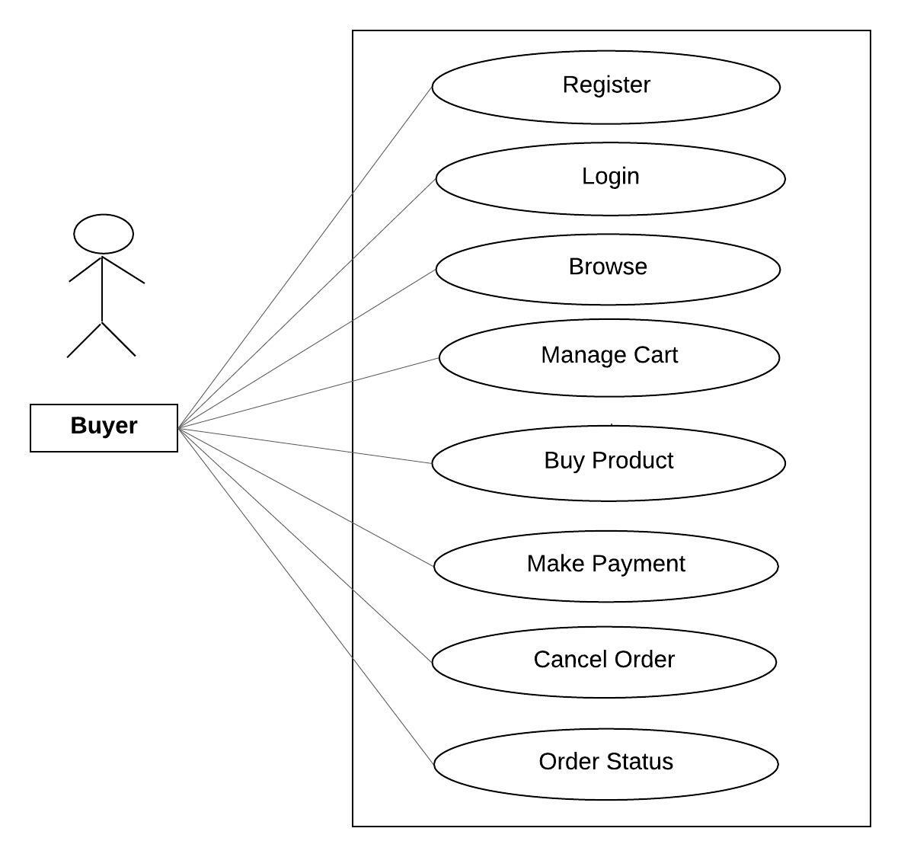

*Fig. Use case diagram for Buyer*

1. In Buyer use case diagram Buyer is the Actor**.**
2. Buyer can handle following use cases:
3. Register
4. Login
5. Browse
6. Manage Cart
7. Buy Product
8. Make Payment
9. Cancel Order
10. Order Status